State of the IOTC Yellowfin Reference Set Operating Model for Management Procedure evaluation March 2021

Dale Kolody (dale.kolody@csiro.au)
Paavo Jumppanen
CSIRO, Australia

Introduction
This document is intended to provide a brief summary of the most recent state of the yellowfin tuna reference set Operating Model (OM) used for Management Procedure (MP) evaluation. The documentation for the latest version of the MSE software, technical documentation, and series of project reports is publicly available from github https://github.com/pjumppanen/niMSE-IO-BET-YFT/. The iterative and sometimes circuitous decision process undertaken by the IOTC technical working groups and analysts to reach the current state of the OM are not described here. These may be found in various IOTC working papers, information papers and meeting reports, along with various model results and diagnostics that were used to guide the OM development process.
As discussed in IOTC-2021-WPM12(MSE)-03, at this time, we do not consider that there is a satisfactory yellowfin Operating Model, with which to present MP evaluation results to the TCMP 2021. We argue that presenting the next iteration of results should be delayed until the full deliberations of the WPTT are conducted in 2021, in relation to the updated data, and rapidly evolving stock assessment process. This appendix describes what we might propose as the best option, if the MSE Task Force judged that something was urgently required:
  - The base 4 area grid (to retain the potential for describing the influence of tags and CPUE disaggregation into tropical and temperate regions)
  - Fractional factorial design much larger than 54 models (i.e. to broaden the diversity of the OM by representing more of the interactions among model options)
  - Diagnostic filtering of models, including:
    - substantial catch likelihood indicating catch removal failure in conditioning
    - A prior weighting on model assumption options similar to that described in IOTC-2021-WPM12(MSE)-03, to reduce the chance of failing to remove observed 2018 and 2019 catches with an effort ceiling of relative to the recent period (a level to be determined by the MSE Task Force (e.g. ~1-3)
  - Bridging catches for 2020 and 2021 determined by projecting the constant effective effort from 2019. As soon as the reported catches from 2020 become available, this should be incorporated in the conditioning or diagnostics.
  - MP implementation with an effort ceiling relative to the recent historical period at a level to be determined by the MSE Task Force (e.g. ~1-3)
This might provide an OM that cannot be immediately dismissed as implausible, but it seems like a superficial plan that does not attempt to address the fundamental retrospective problem that afflicts the stock assessment and OM.
The details below are general characteristics of the YFT OMs under consideration at this time.

Conditioning Software
The OM is an ensemble of models conditioned using the Stock Synthesis assessment software version SS3.24z.exe (e.g. Methot and Wetzel 2013).

Projection Software
The projection software is available from https://github.com/pjumppanen/niMSE-IO-BET-YFT/. The population dynamics equations conform to fairly standard fisheries stock assessment model assumptions, and are fully documented in the technical reference (also on github). In most respects, the OMs attempt to mirror the equations used in fitting a Stock Synthesis model, and the same fixed and estimated parameters are used for the MSE projections. Some deviations are noted below.

Reference Set OM
The various models considered in the OM ensemble are mostly derived from the reference case stock assessment (supplied by Dan Fu, IOTC secretariat, and defined in Fu et al (2018)), with additional modifications from the interim assessment development work described by Urtizberea et al. 2020). Key assumptions include:
- 4 regions (Figure 1) with age-dependent movement. The option of 2 areas remains under consideration, in which the population is split into Western and Eastern Areas, with no movement (this is discussed in the main text).
- Quarterly dynamics (implemented with calendar quarters as SS model-years)
- 25 fisheries (Table 1) - 21 with some temporal variation represented as independent fisheries
- Parameter estimation objective function includes
  - Total catch penalty (active if some component of catch cannot be removed)
  - Standardized longline CPUE (one series per region – constant catchability is assumed following the application of regional scaling factors to establish a relative abundance linked among regions). Regionally-scaled indices from north and south are merged in the 2 area models
  - Size composition data
  - Tags (down-weighted to be essentially excluded in some OM scenarios, including all 2 area models)
  - Recruitment penalties on deviations from stock recruit relationship and mean spatial distribution
  - Diffuse priors on all estimated parameters
- Estimated parameters:
  - Fishery selectivity (various functional forms, parameters shared among some fleets)
  - Longline catchability (in aggregate - regional scaling factors are used to scale relative density to relative abundance among regions)
  - Virgin recruitment
  - Recruitment deviations from the Beverton-Holt stock-recruit relationship, recruitment spatial partitioning among tropical regions (1 and 4) and deviations from the mean spatial distribution.
  - Juvenile and adult movement rates
  - Initial fishing mortality
- Modifications to the reference case assessment for the OM included:
  - Removing the movement-environment link
  - Constraining 12 quarters of recruitment deviations to the stock-recruit function (instead of 8)
  - Adding additional age-dependent error to the terminal SS age structure before the MSE projections begin
  - Relaxing some parameter bounds (i.e. so that an arbitrary hard bound does not constrain parameter estimates)

OM Reference Set Grid
- Model structural and parameter uncertainty would be introduced to the OM through the alternative assumptions listed in Table 2 (4 area grid only). Only the point estimates (maximum posterior density) of parameters and initial states from each model specification are retained for the OM.
- A fractional-factorial experimental design of 50-150 models is used to reduce the dimensionality of the full factorial cross. In an experimental design context, all main effects should be estimable at a minimum.
- In recognition that the IOTC yellowfin assessment model parameter estimates can be sensitive to initial starting conditions, minimization was repeated from randomly jittered starting conditions until either (i) successful minimization was achieved 3 times (maximum gradient of the objective function with respect to the estimated parameters <0.01) or (ii) 10 attempts were made without reaching 3 successful minimizations.
- Projection assumptions are defined in Table 3.

References
Fu, D, Langley, A, Merino, G, Urtizberea, U, 2018. Preliminary Indian Ocean yellowfin tuna stock assessment 1950-2017 (stock synthesis). IOTC–2018–WPTT20–33.

Methot, R.D., Wetzel, C.R. 2013. Stock synthesis: A biological and statistical framework for fish stock assessment and fishery management. Fisheries Research 142 (2013) 86–99.

Urtizberea, A, Cardinale, M, Winker, H, Methot, R, Fu, D, Kitakado T, Fernández, C, Merino, G. 2020. Towards providing scientifc advice for Indian Ocean yellowfin in 2020. IOTC-2020-WPTT22(AS)-21.

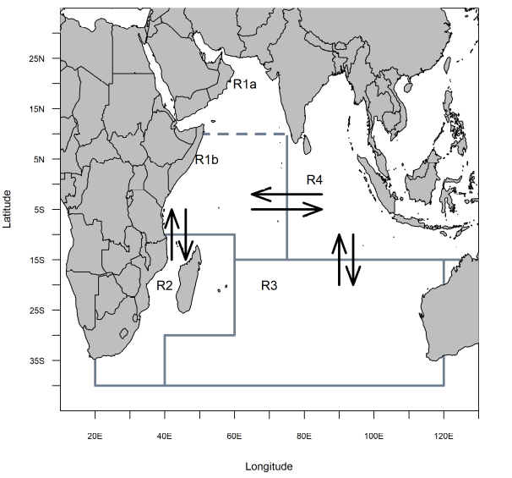
Figure 1. Spatial structure for the yellowfin tuna OM (figure from Fu et al. 2018).

Table 1. IOTC Yellowfin assessment fishery definitions.
Fishery | Definition | Region
1 | Gillnet (GI) | 1
2 | Handline (HD) | 1
3 | Longline (LL) | 1
4 | Other (OT) | 1
5 | Baitboat (BB) | 1
6 | Purse-seine - free schools (FS) 2003-2006 | 1
7 | Longline (LL) | 1
8 | Purse-seine - log schools (LS) 2003-2006 | 1
9 | Troll (TR) | 1
10 | Longline (LL) | 2
11 | Longline (LL) | 3
12 | Gillnet (GI) | 4
13 | Longline (LL) | 4
14 | Other (OT) | 4
15 | Troll (TR) | 4
16 | Purse-seine - free schools (FS) | 2
17 | Purse-seine - log schools (LS) | 2
18 | Troll (TR) | 2
19 | Purse-seine - free schools (FS) | 4
20 | Purse-seine - log schools (LS) | 4
21 | Purse-seine - free schools (FS) pre 2003 | 1
22 | Purse-seine - log schools (LS) pre 2003 | 1
23 | Purse-seine - free schools (FS) post 2006 | 1
24 | Purse-seine - log schools (LS) post 2006 | 1
25 | Longline - fresh tuna (LL) | 4

Table 2. Candidate configurations and assumptions for the reference set OM as defined by WPTT (2020, Table 4)
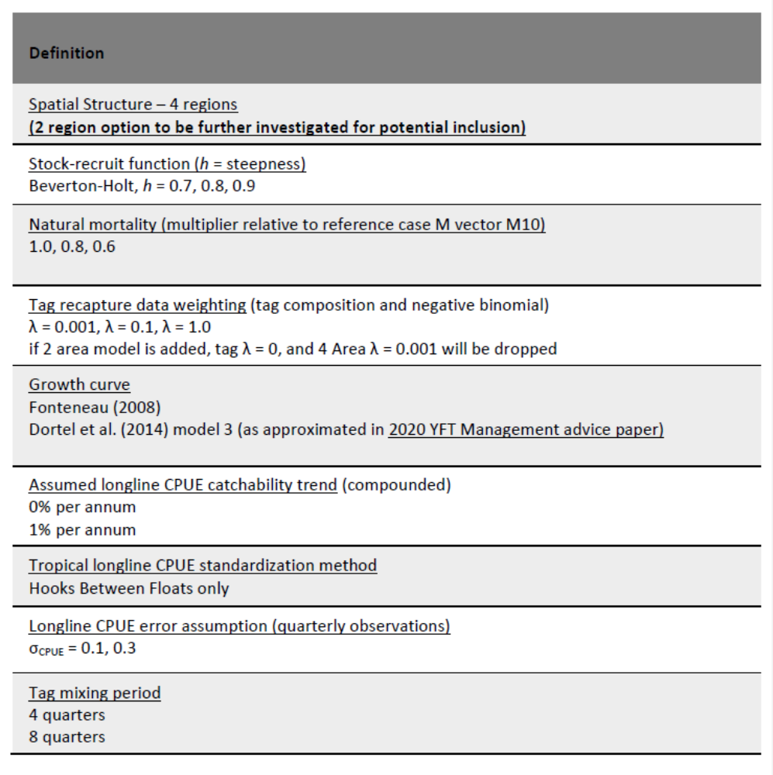

Table 3. OM Projection assumptions in the yellowfin reference set and robustness sets. Reference set values not listed are identical to the model-specific conditioning assumptions/estimates. Robustness case values not listed are identical to the reference set except as noted.
OM | Projection assumption | Value
(TBD) | Reference set OM
 | Initial population error CV  (a = age in quarters) | 0.6exp(-0.1a)
 | Recruitment deviation penalty  Recruitment deviation lag(1) auto-correlation  (these are annual values, but they are parameterized by the quarterly quarterly equivalents) | max(σ_{R} = 0.42, SS estimate)  max(ρ_{R} = 0.21, SS estimate)
 | CPUE observation error  CPUE observation error lag(1) auto-correlation  (implemented annually) | max(σ_{I} = 0.2, SS estimate)  max(ρ_{I} = 0.5, SS estimate)
 | Multinomial Catch-at-length sample size  (all fisheries, but not used in MPs to date) | 100
 | Selectivity stationary for all fisheries
 | Quota Implementation error | CV = 0
 | First MP quota year | 2022
 | Bridging catches 2018, 2019-2021 (1000 t) | 440, 417
 | MP data lag  (i.e. data from 2018 informs 2021 quota) | 2 years
 | Quota allocation (average observed over period) | 2016-2017
 | Baranov Catch Equation  Seasonal F averaged over SS period  Effort Ceiling (relative to seasonal F above) | 2016-2017  20
 | Robustness tests (other features as reference set)
- Increased Longline CPUE error variance
σ_{I} = 0.3, ρ_{I} = 0.5
 | - 10% overcatch, accurately reported
 | - 10% overcatch, unreported
 | - 10% overcatch, 5% reported, 5% not reported
 | - 8 consecutive quarter recruitment shock (55% of average, near start of projections)
- 3% per year LL catchability trend
(not in SS conditioning; projections only)

